TASK 6 – Design the control structures
Use switch to select the base fare for a zone, if-else to allow or deny travel, and a loop to process multiple journeys. A for loop is suitable when the number of journeys is known. A range-based for loop is convenient when iterating over a stored collection. A while loop is useful when input continues until a stop condition. Use continue to skip an invalid journey and break to stop processing when required.

Pseudocode
BEGIN
READ zone and peakFlag
IF zone is invalid THEN
DISPLAY "Invalid zone"
STOP this journey
ENDIF
SELECT baseFare USING zone
Inner : baseFare = 1000
Middle : baseFare = 2000
Outer : baseFare = 3000
ENDSELECT
fare = baseFare
IF peakFlag THEN
fare = fare + (baseFare * 20 / 100)
ENDIF
IF balance - fare >= 5000 THEN
balance = balance - fare
DISPLAY fare and balance
ELSE
DISPLAY "Denied"
ENDIF
END

Completed TODO 1 and TODO 2 program
#include <iomanip>
#include <iostream>
enum class Zone { Inner, Middle, Outer };
constexpr long long BASE_PAISE[] = {1000, 2000, 3000};
constexpr int PEAK_SURCHARGE_PERCENT = 20;
constexpr long long MIN_BALANCE_PAISE = 5000;
long long fare(Zone z, bool peak) {
long long base = 0;
switch (z) {
case Zone::Inner: base = BASE_PAISE[0]; break;
case Zone::Middle: base = BASE_PAISE[1]; break;
case Zone::Outer: base = BASE_PAISE[2]; break;
default: return 0;
}
if (peak) {
base += base * PEAK_SURCHARGE_PERCENT / 100;
}
return base;
}
bool canTravel(long long balance, long long f) {
return f > 0 && balance - f >= MIN_BALANCE_PAISE;
}
int main() {
long long balance = 10000;
struct Trip { Zone zone; bool peak; };
Trip trips[] = {
{Zone::Inner, false},
{Zone::Outer, true},
{Zone::Middle, false}
};
for (const Trip& t : trips) {
long long f = fare(t.zone, t.peak);
if (canTravel(balance, f)) {
balance -= f;
std::cout << "Fare Rs " << f / 100 << '.'
<< std::setw(2) << std::setfill('0') << f % 100
<< std::setfill(' ');
} else {
std::cout << "Denied (low balance)";
}
std::cout << " balance Rs " << balance / 100 << '\n';
}
}

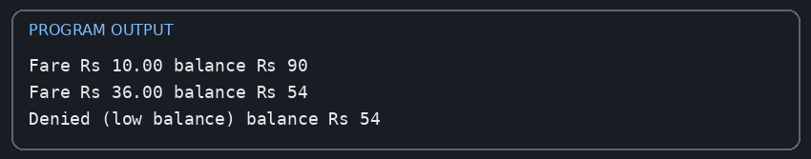
Executed output
Fare Rs 10.00 balance Rs 90
Fare Rs 36.00 balance Rs 54
Denied (low balance) balance Rs 54

The output matches the assignment's expected result: Rs.10.00 leaves Rs.90; Rs.36.00 leaves Rs.54; the final Rs.20 fare is denied because it would leave less than Rs.50.
Boundary check: the correct peak condition is hour >= 8 && hour < 10 || hour >= 17 && hour < 20. Therefore 08:00 and 17:00 are peak; 10:00 and 20:00 are not peak.

Alternative concept and complexity
An array indexed by zone can replace the switch. Both approaches provide O(1) fare selection. The array stores three fare values. A fourth zone requires adding a new enum value and array entry, while a switch requires adding another case. A table-based design may be easier to extend when zones increase.

